As of September 2021, the Davis Educational Foundation has transitioned to an online application and reporting portal for Implementation Grants. Applicants need to create a username and password to access the application.
The following are step-by-step instructions to create an account to submit an application. You may sign in at any point after that to continue to work on an application in progress before the deadline. If you have any problems or questions, do not hesitate to contact DEF staff at def@davisfoundations.org for assistance.
- Click the link below (also posted on our website):
https://davisfoundations-portal.givingdata.com/campaign/2021DEFImplementation
- You should see this Sign In box on the right-hand side of your browser window:
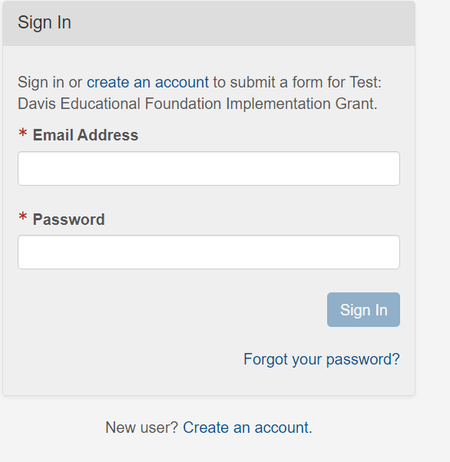
Click either of these links to create an account.
Enter your email address:
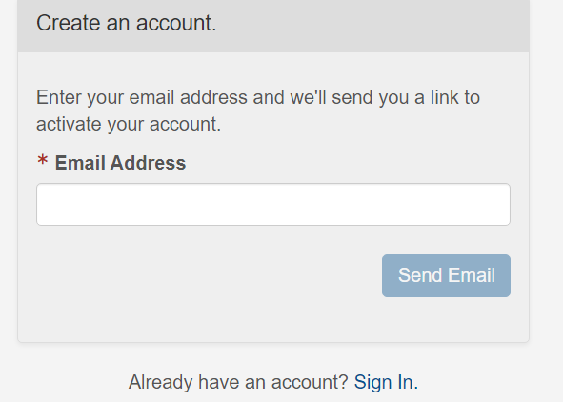

Enter your email address here, and click Send Email.

You should now see the following message:
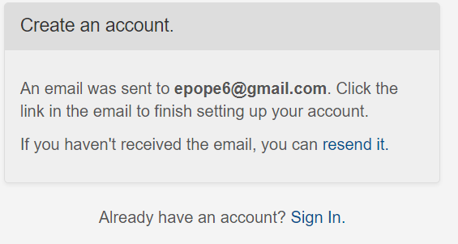
Your email appears here
- Check the email you used above for a message with the subject line “Davis Educational Foundation Grantee Portal Account Registration”.
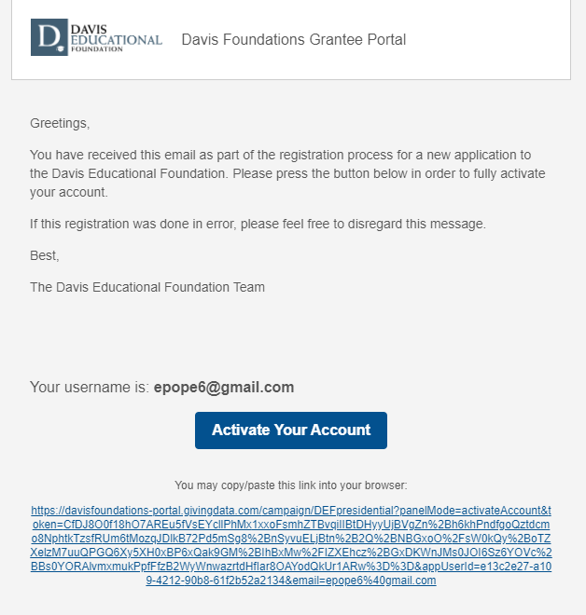
Your email appears here
Your email appears here

Click this button or copy/paste the link from your email inbox to your browser window.

- You will then be taken to a screen in your browser window and prompted to Activate your Account:

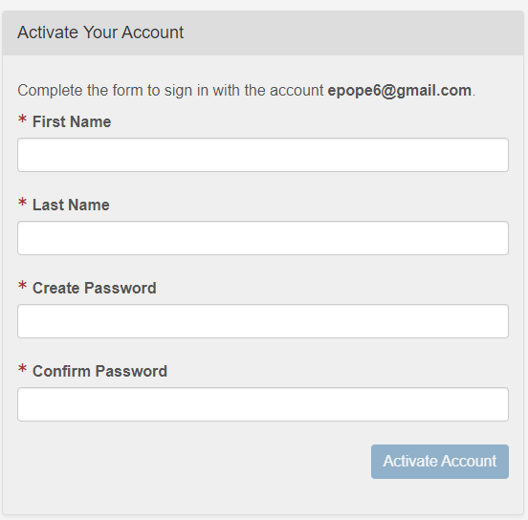
Your email appears here

Complete the form and choose a password.

You will then be prompted to Sign In with your new credentials.

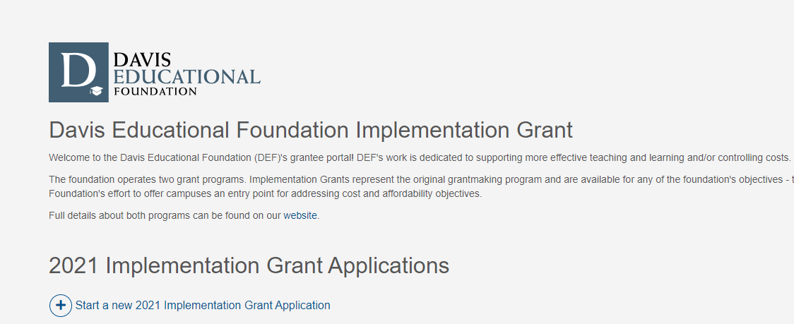
- You should see the following display:

Click the plus sign to start a new application.

- You will be prompted to select the organization for which you are applying for grant funds. Please use the U.S. Tax ID number or Organization Legal Name to find the organization in the IRS database.

- Select the correct organization and proceed with the application, following the prompts and instructions within the application form. You can consult a Word or .pdf version which will preview all questions asked in both applications on our website here: https://davisfoundations.org/def/apply

- To sign in to a saved application, simply navigate to the portal website (https://davisfoundations-portal.givingdata.com/) and sign in with your username and password.

- If you forget your password, you can use the “Forgot your password?” link and you will be emailed a link to reset it.

