Davis Family Foundation

Online
Application
Guide
Getting started Login or create an account…
Please note: If you have applied to the Davis Conservation Foundation you should use the same login information for Davis Family Foundation.
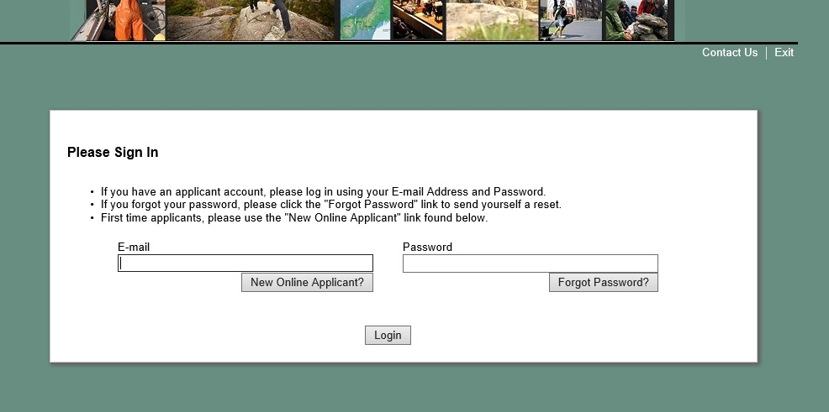
Click Login to start your new application.
If this is your first time applying to the Foundation using the online application, create an account here.
**Helpful Tip** Your organization should only have one account. We recommend an info@... email address.
What if you forgot your password? Click here to receive an email with a new password.
If you have an existing account from a previous grant round, enter an email and password.
The email address associated with your online account will receive notification when:
You create an account
You save a draft of your application
You submit your application
You click “Forgot Password”
Your grant completion report is due
You save a draft of your grant report
You submit your grant completion report
Before You Begin
This is the page you will see when you log in. Please review these instructions carefully.

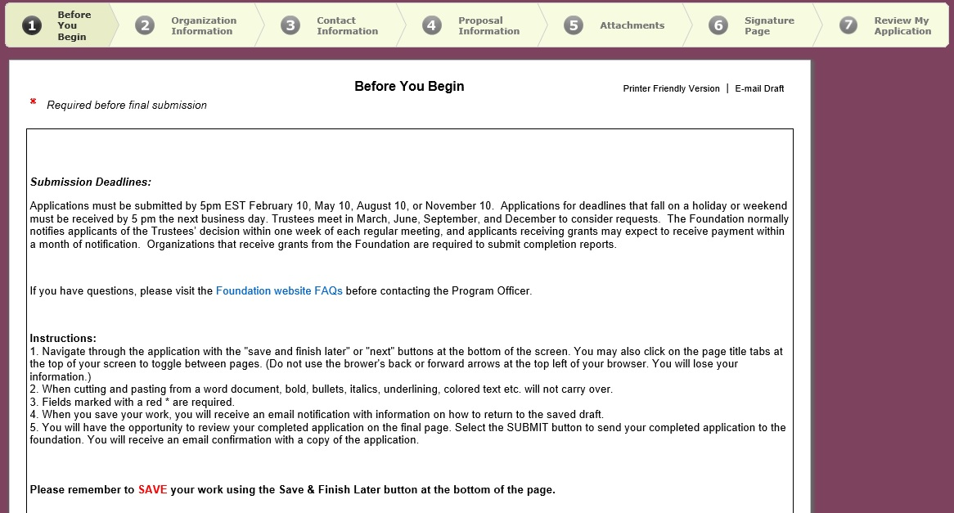
Navigating the Application
Navigation Tabs guide you through the application. Select one to go to that page.
Click Exit to log out.
The page you are on is bold and highlighted.

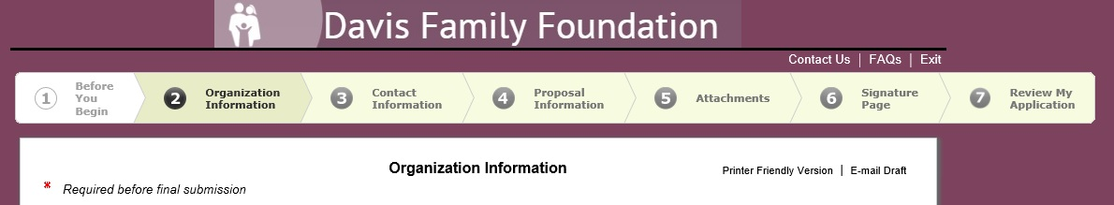
Print or email the application with these buttons.

You can save your application at any time and return to it later, or proceed to the next page.
This is at the bottom of every page except the last.

***Helpful Tip*** Save your application often. This will not log you out, but will take you to your account homepage.
Uploading Attachments

Step 1 -- Click “Browse” to select your document

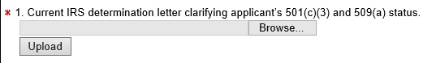

Step 2 -- Click “Upload” to attach your document

Step 3 – You will see the document name, date uploaded, and file size when it is attached

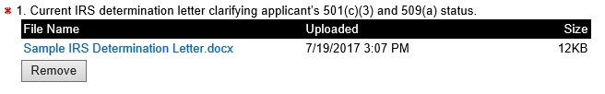

Your Account Homepage
When you select the “Save and Finish Later” button, you are taken to your account page.
You will also get to this page when you log into your account once your application is in process,
and when you login to submit your completion report, if awarded.

When you log in to your account you land on the “Applications” page.
If awarded a grant, grant reports are posted under the “Requirements” page. Click the button to navigate to that page.
The drop down menu allows you to select to view your In Progress or Submitted applications or Requirements.

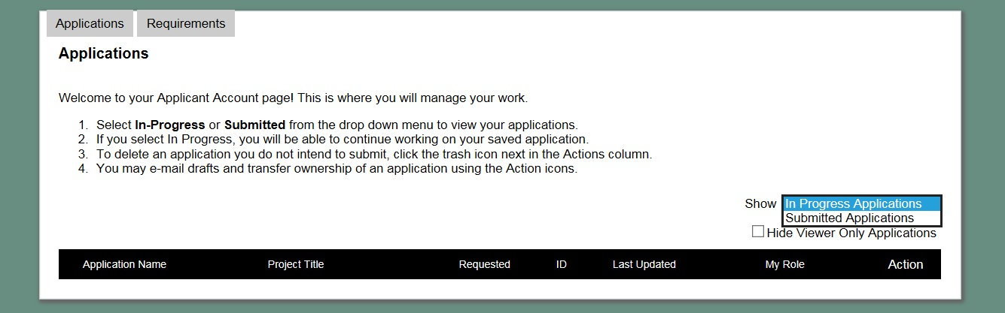

Troubleshooting

Problem | Solution
I am signed in to my account but I can't find where to start a new application. | Even if you have an existing account, all new applications MUST be started by clicking the "New Application" link found on the Apply page of the website.
Our staff has changed, and we lost our login information. | Contact staff to update your account to a new email address. Using "info@..." or a more generic account for your organization may help alleviate this problem in the future.
One of my documents will not attach. | Chances are your file is too big (no 990s please!). Sometimes using a PDF can help. If it continues to fail to attach, please contact staff for assistance.

Contact: Katie Paye, Program Officer kpaye@davisfoundations.org (207) 846-9132 x 13
Lisa Smith, Grants Associate lsmith@davisfoundations.org (207) 846-9132 x 16

